Rakuten LBJ program- BE track- Final Project

Business-Requirement: An Overview
Before beginning work on any project, it's usually a good idea to know what you're building. Below is a basic list of things we want our users to be able to do:
The client would like to develop an independent application; Personal Workout Tracker single page app; which is used to manage personal workout and fitness plans.
Workout Tracker:
- This web application allows user to enter in and save the workout plans.
- Each new workout entered by user will capture calories burnt per min along with
- It will allow you to start the workout and end the workout whenever the user does the workout and ends the workout respectively.
- It will provide report on number of calories burnt.

Business-Requirement: Summary
Workout Tracker
- Add/Update/Delete/View Workout
- Add/Update/Delete/View Category
- Start Workout
- End Workout

Wireframes

Wireframe: Start Workout Screen
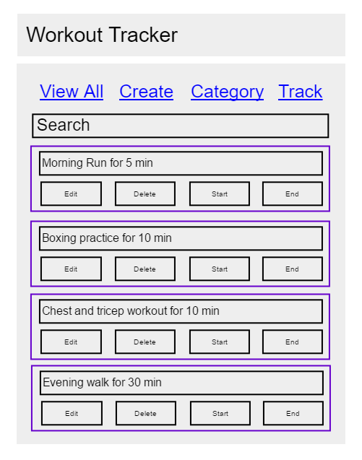
Remain disabled by default. It will be enabled only after the particular workout is started by clicking on start button
It has a functionality of autofilter. It will filter the search results based on what user types in the search box. It is implemented using angular-js filter.
- Displays the list of workout ideas entered by user.
- User can edit, delete the workout
- User can start the workout when user wants to start the workout. It will get disabled after the workout is started.
- User can end the workout after user is done with the workout. It is disabled by default. It will be enabled only if workout is started.
- The screen has a search bar with auto-filter enabled i.e. as user types the workout; he/she wants to search the results will get auto filtered below.
- Navigation in the website happens as a SPA (Single Page Application)
Wireframe: Add Workout Screen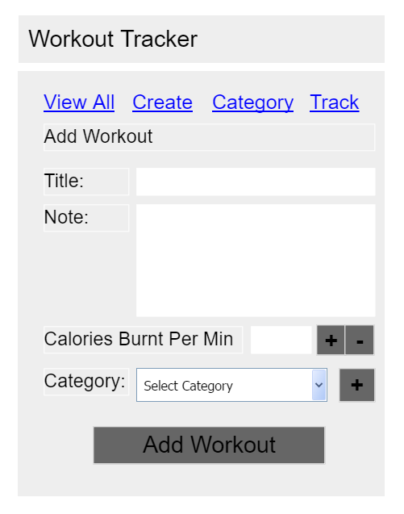
When the page loads, ‘Add Workout’ is disabled. It gets enabled only after the Title, Calories Burnt Per Min and Category is selected.
Floating Point Numbers only .
- Clicking on + will add by 0.1
- Clicking on – will decrease by 0.1
- This screen allows you to add the workout.
- You can also manage the category to which workout belongs in this screen.
- You will need to input the calories burnt per min if the user does this workout.
- Ref: https://whatscookingamerica.net/Information/CalorieBurnChart.htm
Wireframe: Add Workout Screen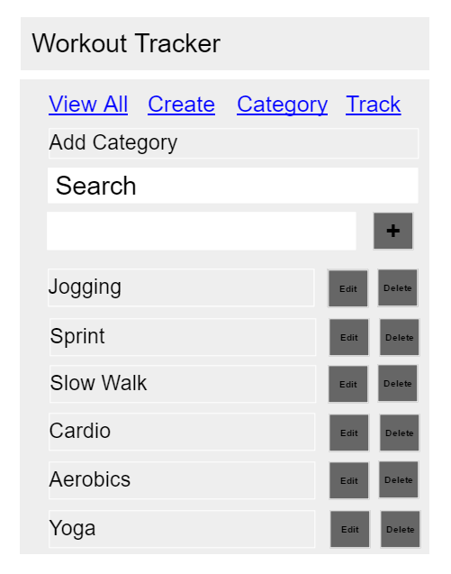
Proper validation should be in place to prevent user from entering blank category
- It allow user to manage categories
- The screen has auto-search box which will allow user to filter the search results while typing in the search box.
Wireframe: Edit Workout Screen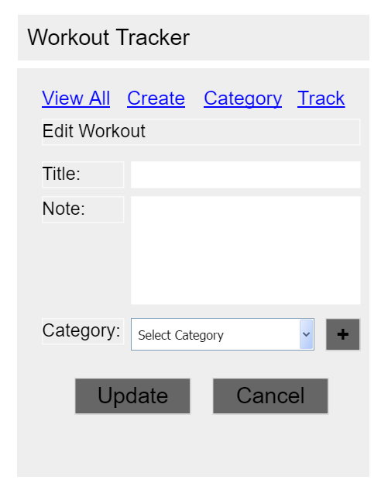
- It allows users to edit any workout they may have entered
Wireframe: End Workout Screen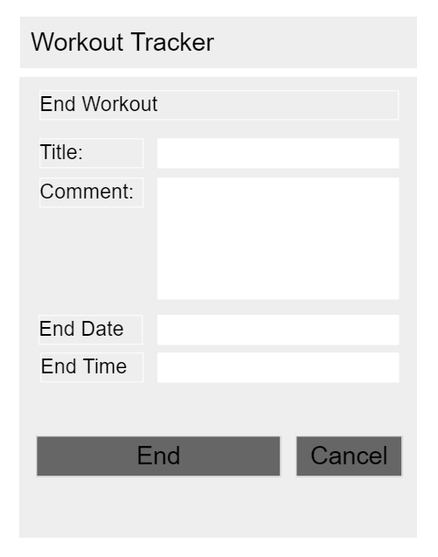
Date Format. By default, populated with current date
Time Format. By default, populated with current time
- It allows users to end the workout which is already started.
- Users can input the end date and end time.
- By default workout title is populated. This is un-editable.
- By default current date and current time is populated.
Wireframe: Start Workout Screen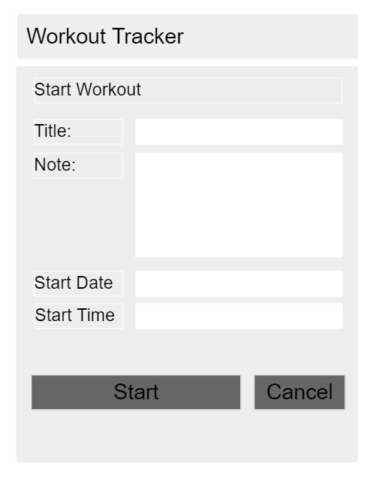
Date Format. By default, populated with current date
Time Format. By default, populated with current time
- It allows users to start the workout.
- Users can input start date and start time.
- By default, workout title is populated. This is un-editable.
- By default, current date and current time is populated.

